Goals of ST:

<https://www.geeksforgeeks.org/goals-of-software-testing/>

1. Immediate goals:
2. Bug Discovery
3. Long term goals
4. Quality
5. Customer satisfaction
6. Reliablity
7. Risk Management
8. Post implementation goals
9. Reduce Maintainance cost
10. Improve Software Testing process
11. Bug Prevention

Software testing

<https://www.geeksforgeeks.org/software-testing-basics/>

Model for ST:

<https://www.ques10.com/p/48600/model-for-software-testing/>

Why Complete Exhaustive Testing is not possible?

1. Time consuming
2. Complex
3. Design Issues
4. Time constraint
5. Different users
6. Testing situations
7. Manual Testing

| **Parameters** | **Exhaustive Testing** | **Effective Testing** |
| --- | --- | --- |
| **Definition** | Test the software for all possible input values. | It tests the effectiveness of an application and tests particular functions for given resources. |
| **Feasibility** | It is practically not possible. | It is possible to test the system. |
| **Time** | It is very exhaustive and time-consuming. | It does not take much time for the testing team. |
| **Approach** | Mostly it is documented and theoretical approach. | It is a completely practical approach and the tester test the effectiveness of the system. |
| **Cost** | It is costly process due to exhaustive nature of checking all testcases. | It is economic and does not extend the budget boundaries of the customer. |
| **Scope** | It is complete testing and covers all possible test scenarios. | It prioritizes test scenarios and smart testing techniques. |

Domain of Input Data:

1. Valid inputs
2. Invalid inputs
3. Edited inputs
4. Race condition inputs

STLC:

<https://www.geeksforgeeks.org/software-testing-life-cycle-stlc/>

1. Requirement analysis
2. Test planning
3. Test Case development
4. Test Environment setup
5. Test Execution
6. Test Closure

Software Testing Methodologies:

1. Waterfall Method
2. Requirements
3. Design
4. Implementation
5. Verification
6. Maintainance

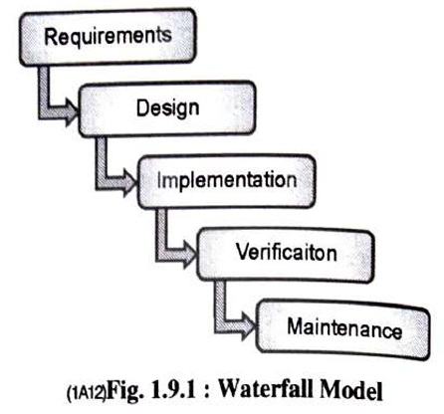

1. Agile methodology

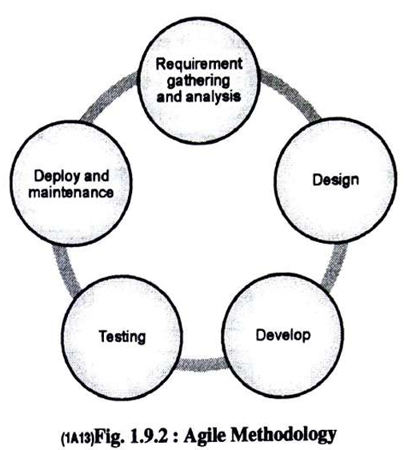

1. Iterative Development

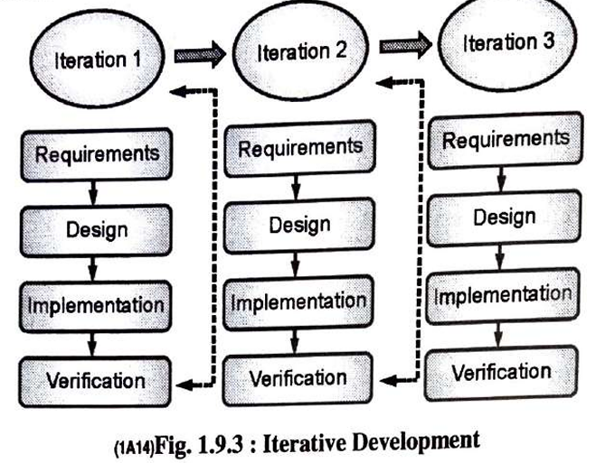

Verification and validation

| **Verification** | **Validation** |
| --- | --- |
| It includes checking documents, design, codes and programs. | It includes testing and validating the actual product. |
| Verification is the static testing. | Validation is the dynamic testing. |
| It does *not* include the execution of the code. | It includes the execution of the code. |
| Methods used in verification are reviews, walkthroughs, inspections and desk-checking. | Methods used in validation are Black Box Testing, White Box Testing and non-functional testing. |
| Verification refers to the set of activities that ensure software correctly implements the specific function. | Validation refers to the set of activities that ensure that the software that has been built is traceable to customer requirements. |
| It can find the bugs in the early stage of the development. | It can only find the bugs that could not be found by the verification process. |
| The goal of verification is application | The goal of validation is an actual product. |
| Quality assurance team does verification. | Validation is executed on software code with the help of testing team. |
| After a valid and complete specification the verification starts. | Validation begins as soon as project starts. |
| Verification is for prevention of errors. | Validation is for detection of errors. |
| Verification is also termed as white box testing or static testing as work product goes through reviews. | Validation can be termed as black box testing or dynamic testing as work product is executed. |
| Verification finds about 50 to 60% of the defects. | Validation finds about 20 to 30% of the defects. |
| Verification is based on the opinion of reviewer and may change from person to person. | Validation is based on the fact and is often stable. |
| Verification is about process, standard and guideline. | Validation is about the product. |

Software Verification Requirements

1. Due date and warning date
2. Level
3. From and to dates
4. Minimum items
5. Mandatory or not
6. Client supplied
7. Re-verification
8. Recertify always
9. Recertify if changed
10. Never recertify

